**CHRIST (Deemed to be University)**

**Department of Computer Science**

**MSc – Artificial Intelligence and Machine Learning**

**Name:** Syed Mohammed Luqmaan (2448552)

**Course:** Java Lab

**Lab Experiment:** 4

**Description:**

**This Java program models a "robber" who calculates the maximum possible money he can rob from different types of house layouts without setting off security alarms. It includes an abstract Robber class, which outlines the structure with methods for each house layout type: RowHouses, RoundHouses, SquareHouse, and MultiHouseBuilding.**

**The JAVAProfessionalRobber class implements each of these methods:**

* **RowHouses: Calculates the max money from a row of houses, skipping adjacent ones to avoid alarms.**
* **RoundHouses: Similar to RowHouses but considers the first and last houses as adjacent (circular layout).**
* **SquareHouse: Uses the same logic as RowHouses for simplicity.**
* **MultiHouseBuilding: Calculates the max money from multiple building layouts, each represented as an array.**

**The program applies basic dynamic programming concepts to ensure no adjacent houses are robbed in any layout. It also includes a MachineLearning method for fun, which simply prints "I love MachineLearning." This project demonstrates inheritance, abstraction in Java.**

**Screenshots:**

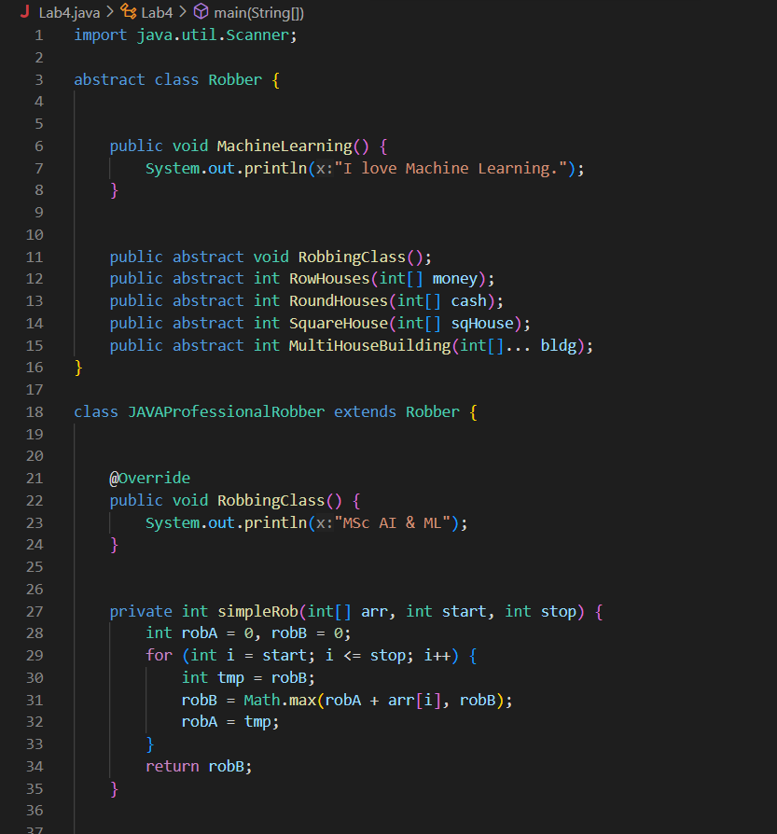

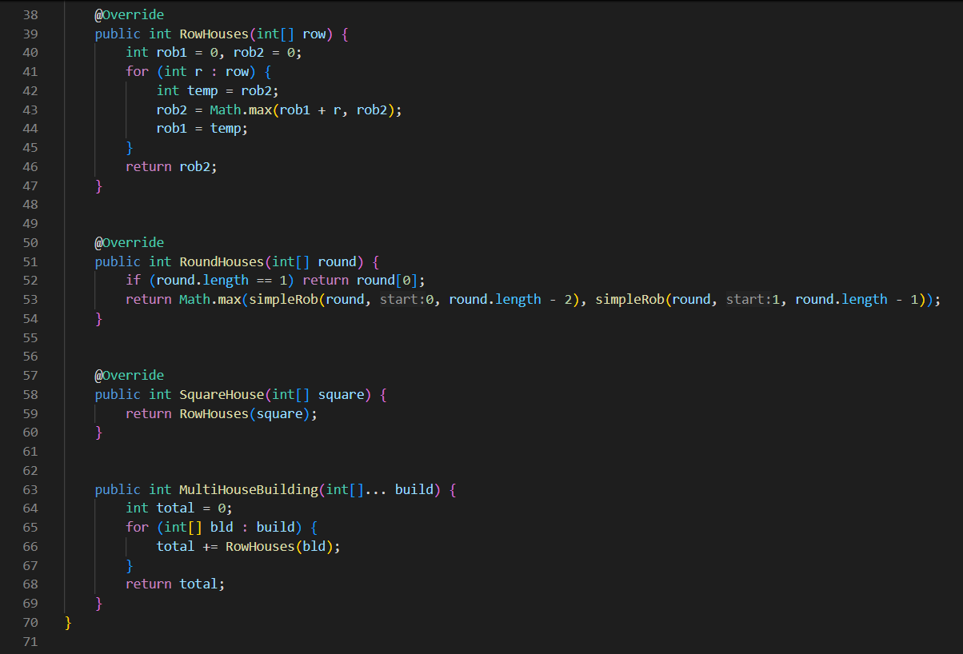

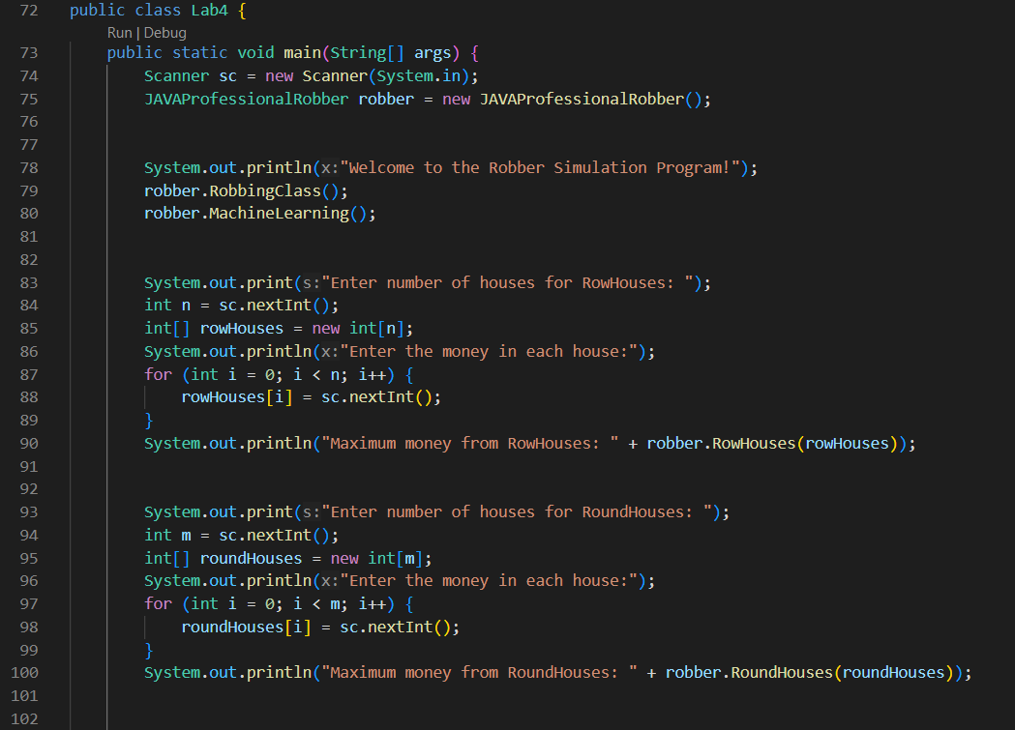

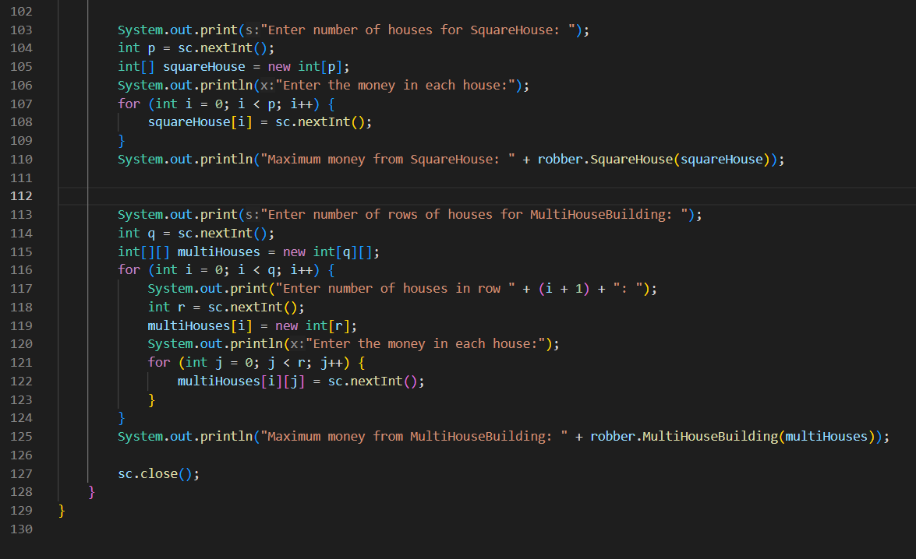

**Output:**

